Mandatory reporting of child sexual abuse consultation
Confidentiality
Information provided in response to this consultation, including personal information, may be published or disclosed in accordance with the access to information regimes (these are primarily the Freedom of Information Act 2000 (FOIA), the Data Protection Act 2018 (DPA), the UK General Data Protection Regulation (GDPR) and the Environmental Information Regulations 2004).
If you want the information that you provide to be treated as confidential, please be aware that, under the FOIA, there is a statutory Code of Practice with which public authorities must comply and which deals, amongst other things, with obligations of confidence. In view of this it would be helpful if you could explain to us why you regard the information you have provided as confidential.

If we receive a request for disclosure of the information we will take full account of your explanation, but we cannot give an assurance that confidentiality can be maintained in all circumstances. An automatic confidentiality disclaimer generated by your IT system will not, of itself, be regarded as binding on the Home Office.
The Home Office will process your personal data in accordance with the DPA and in the majority of circumstances, this will mean that your personal data will not be disclosed to third parties.

(Please type your response, if any, here.)
About you

Question 1.

Tom Perry

Mandate Now

Question 2. Address and postcode

Redacted

Question 3. To help us analyse our responses, could you please tell us in what capacity you are responding to this consultation.
(Please delete the responses which don’t apply.)
Child or young person under age 18
- Other
If you chose ‘other’ or wish to clarify your response, please describe the role that best describes you.
Mandate Now is the pressure group that has led the agenda for the introduction of well-designed mandatory reporting of suspected and known child sexual abuse by prescribed personnel working in Regulated Activities.
Question 4. If you are responding on behalf of a group or organisation, what is your role within that organisation?
- Director
If other, please let us know more about your role.
(Please type your response here.)
Question 5. If you are a representative of a group or organisation, please tell us its name and give a summary of the people or organisations that you represent.
Mandate Now: a pressure group that leads the agenda for the introduction for well-designed mandatory reporting of known and suspected child sexual abuse by prescribed personnel working in Regulated Activities.

Diversity

We know that we deliver better services when we receive feedback from a full range of backgrounds and experiences in the society we serve. We would be grateful if you could complete the following diversity questions. You can select ‘prefer not to disclose’ if you would rather not answer any question.
Question 6. What is your sex?
(Please delete the responses which don’t apply.)
- Male
Question 7. What is your ethnic origin?
(Please delete the responses which don’t apply.)
- White-English
- White-Welsh
- White-Scottish
- White-Northern Irish
- White-British
- White-Irish
- White-Gypsy or Irish Traveller
- White-Roma
- Any other white background
- White and Asian
- White and black African
- White and black Caribbean
- Any other mixed or multi-ethnic background
- Asian or Asian British-Bangladeshi
- Asian or Asian British-Indian
- Asian or Asian British-Pakistani
- Asian or Asian-British: any other Asian background
- Black or black British-African
- Black or black British-Caribbean
- Any other black background
- Arab
- Other ethnic group
- Prefer not to disclose

The mandatory reporting duty

Question 8. In sharing findings from this consultation, may we quote from your response?
(Please delete the responses which don’t apply.)
- No

Question 9. In addition to the definition of ‘regulated activity in relation to children’ provided by the Independent Inquiry, the government is proposing to set out a list of specific roles which should be subject to the mandatory reporting duty. Which roles do you consider to be essential to this list:

It should be according to the updated Schedule that originated in the now lapsed Private Members Bill tabled by Baroness Tanni Grey-Thompson: “Regulated and Other Activities (Mandatory Reporting of Child Sexual Abuse) Bill”[HL] – see list below.
Having more than one safeguarding protocol across a range of children’s settings would create confusion. The recommendations made by the Australian Royal Commission into Institutional Responses to Child Sexual Abuse has seen all but one State rapidly move towards one safeguarding framework with mandatory reporting protocols of broadly similar design.
The current safeguarding framework, as applied to Regulated Activities in England and Wales, serves them poorly. The safeguarding framework in the UK is dominated by neglect of children in the family. Unfortunately, it takes little account of the entirely different demands of Regulated Activity personnel. Most of these professionals’ work in complex and strategically important institutional settings. They have key ‘sentinel’ safeguarding (and reporting) roles that can so improve children’s safeguarding when, as Australian data reveals, they are supported by well-designed law that mandates the reporting of suspected and known child sexual abuse. Its introduction must be preceded by safeguarding training provided by accredited safeguarding trainers. No accreditation scheme exists for anyone who provides this training.
Future mandated reporters must include those working in:

REGULATED AND OTHER ACTIVITIES
- Education including—
  - schools,
  - sixth form colleges,
  - colleges of further education,
  - pupil referral units,
  - residential special schools,
  - hospital education trusts,
  - settings of education other than at schools,
  - private tuition centres.
- Healthcare including—
  - hospitals,
  - hospices,
  - GP surgeries,
  - walk-in clinics,
  - outpatient clinics.
- Others including—
  - child nurseries and kindergarten provision,
  - childminders and childcare providers registered on the early years register or the compulsory or voluntary part of the childcare register,
  - registered social care providers and managers for children,
  - children’s homes,
  - children’s hospices,
  - youth offender institutions,
  - the Probation Service,
  - private institutions contracted by public bodies to provide services to children,
  - organisations providing activities to children, such as sports clubs, music, dance or drama groups, youth clubs, and Ministry of Defence cadet forces including Sea Cadets, the Volunteer Cadet Corps, the Army Cadet Force, the Air Training Corps and the Combined Cadet Force, Fire Cadets,
  - organisations providing holidays for children or supervising children while on holiday,
  - churches, mosques, synagogues, temples, and other places of worship and religious organisations, and other organisations holding non-religious worldviews,
  - services offered to children by local authorities outwith their statutory duties,
  - services offered to children by the police outwith their statutory duties
  - transport services including taxis and coaches commissioned by the providers of the regulated activities in this Schedule.

Question 10. What would be the most appropriate way to ensure reporters are protected from personal detriment when making a report under the duty in good faith; or raising that a report as required under the duty has not been made?
Please provide details to explain your response.
The protections described in sections 3(2), 3(3) and 3(4) of our recently updated model for mandatory reporting of known and suspected child sexual abuse are appropriate and proportionate and have operating precedent in numerous common law jurisdictions.
- Offences
  - Failure to fulfil the duty set out in section 1 before the expiry of the period of seven days of the matter, allegation or suspicion first coming to the knowledge or attention of the provider or of any person whose services are used by the provider as defined in section 2 is an offence.
  - A person who causes or threatens to cause any detriment to a mandated person, being a person placed under the duty to report pursuant to section 1 above, or to another person, either wholly or partly related to the mandated person’s actual or intended provision of a report under this Act, is guilty of an offence.
  - Detriment includes any personal, social, economic, professional, or other detriment to the person.
  - A person guilty of an offence under section 3(1) is liable on summary conviction to a level 5 fine on the standard scale.
  - A person guilty of an offence under section 3(2) is liable on summary conviction to a level 4 fine on the standard scale.
Question 11. In addition to the exception for consensual peer relationships, are there any other circumstances in which you believe individuals should be exempt from reporting an incident under the duty?
Please provide details to explain your response.
In our submission to the public consultation on Mandatory Reporting which closed on 14th August 2023 (starting at page 15), we provided an alternative proposal to the IICSA recommended exception for consensual peer relations. Question 11 assumes those who complete this submission agree with the IICSA exemption. We do not agree and provide a copy of our response to Question 19 the earlier consultation.
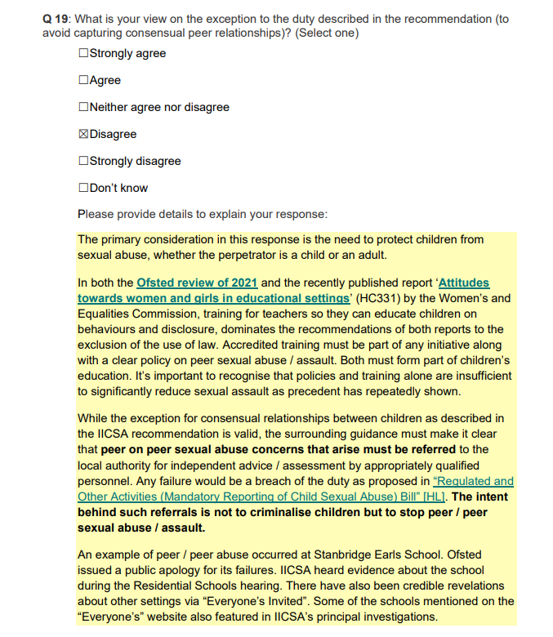
Having addressed the incorrect assumption that we agree with IICSA's exception, below is another extract from our submission to the public consultation about ‘exemptions’:
Where the mandated reporter can show that a report has already recently been made. Section 4 of the updated draft legislation provides for this and other appropriate defences. Sections 2(7) and 2(8) of the same Bill provide the Secretary of State with powers to exempt an organisation or individuals in prescribed circumstances.
Section 2
- The Secretary of State may, in exceptional cases, issue a suspension document to rescind or temporarily suspend the duty referred to in section 1 in the case of any specified child or children if it appears to the Secretary of State that the child’s welfare, safety or protection would be prejudiced or compromised by the fulfilment of the duty.
- Where it appears to the Secretary of State that the welfare, safety and protection of children is furthered, he or she may exempt—
    - any specified organisation that works with children generally, and its members, or
    - any specified medical officer, from compliance with the duty referred to in section 1 provided that no allegation is made against that entity or person.
- The Secretary of State may make regulations varying or adding to or deleting from the list of activities in the Schedule, whether or not such activities are defined in any enactment as regulated activities involving children.

Question 12. We are proposing that there would be criminal sanctions where deliberate actions have been taken to obstruct a report being made under the duty. What form of criminal sanction would you consider most appropriate?
- Fines on summary conviction but see answer to Question 13.
Question 13. Should situations where a reporter has been obstructed due to active indifference or negligence also be subject to these sanctions?
It appears that a key point of well-designed mandatory reporting of suspected and known child sexual abuse has not been understood by the author of this questionnaire. Mandated reporters report a concern directly to the local authority (or their equivalent in each MR jurisdiction). This question was asked of Professor Ben Mathews at IICSA MR seminar #2. His answer is below:
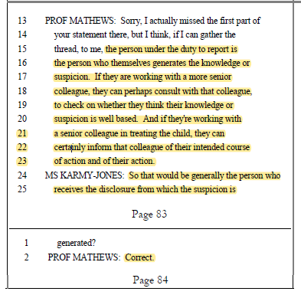
We know of no jurisdiction with well-designed mandatory reporting of known and suspected child sexual abuse that has law for obstruction. It’s unnecessary.

Question 14. We would like to test the view that professional and barring measures apply to those who fail to make an appropriate report under the duty. Do you agree with this approach? Would different situations merit different levels or types of penalty?
We disagree.
Concerning professional sanctions against individuals, they do no harm but are not a substitute for well-designed statutory legislation that mandates reporting of suspected and known child sexual abuse that by default carries a criminal sanction as featured in our updated model. The Irish Republic introduced mandatory reporting in name only i.e. without criminal sanction, in 2017. Unfortunately, there is still no data available from the Republic from which comparisons with Australian jurisdictions can be made. But we can consider what should have happened thanks to a comparative analysis in 2010 between the State of Victoria and the Republic before it adopted its unusual model of mandatory reporting. This was presented to IICSA MR seminar 2 in April 2019.
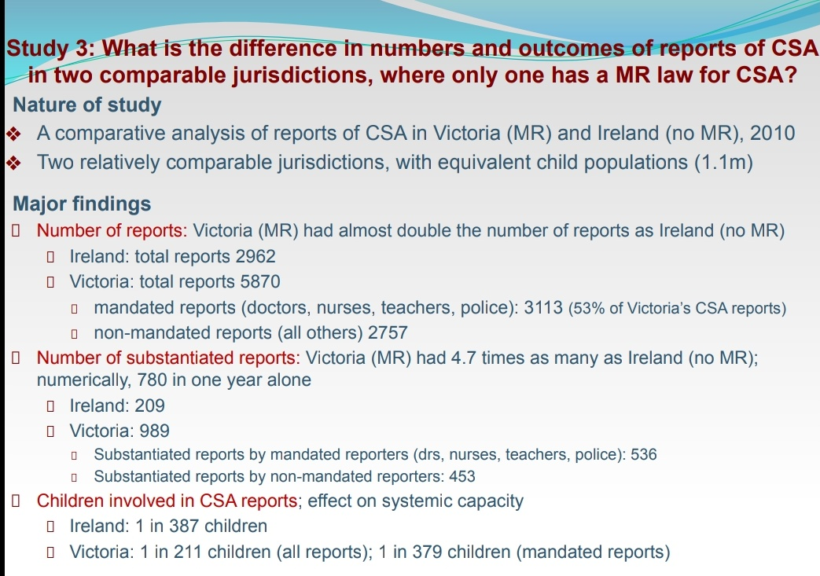
We are keen to know whether Ireland has achieved this hoped-for improvement with legislation that doesn’t conform to designs known to be successful. 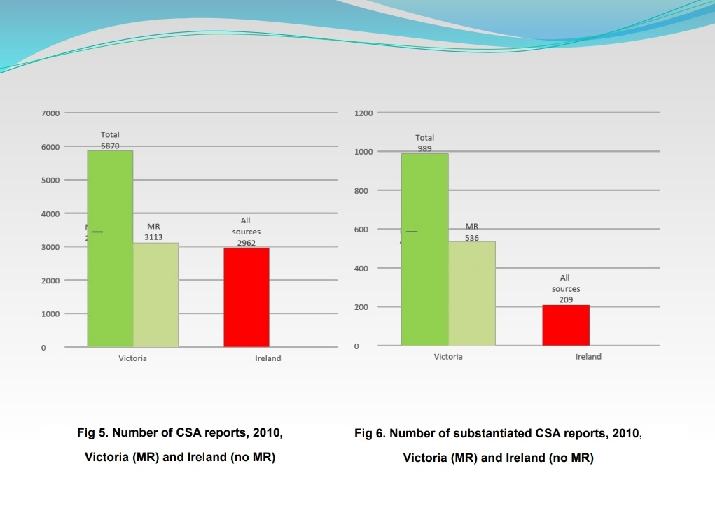
On the subject of using the DBS in the way as suggested in this questionnaire, there is already a mandate for the ‘owner’ (Chair of Trustees / Governors) of a setting to make a referral to the DBS in prescribed circumstances (Section 35-38 of SVGA 2006 as amended 2012) which has been proven to be and remains wholly unreliable. Mandate Now wrote to the Chair of IICSA about this unsatisfactory set of circumstances from which we provide the extract below:

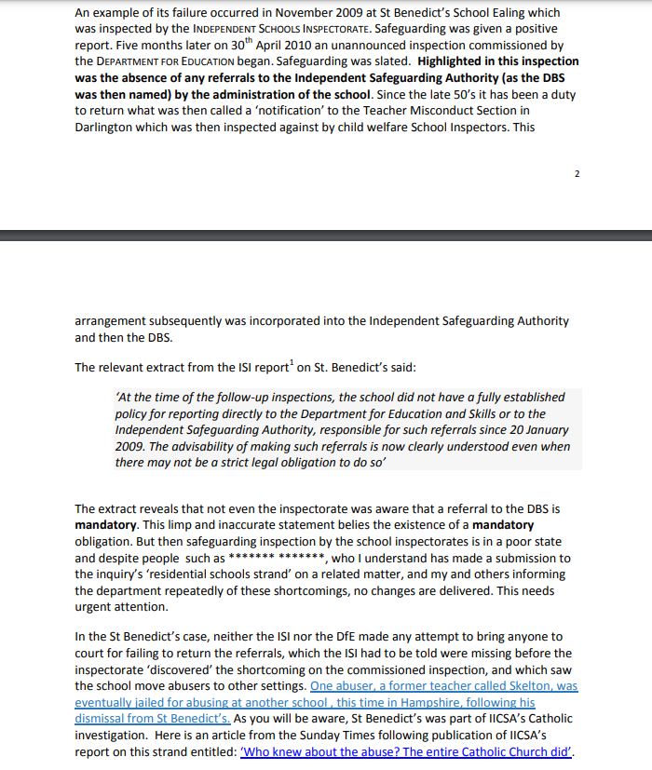
Our submission led to this exchange between counsel to the inquiry and Dr Suzanne Smith (Director of Safeguarding DBS) while giving evidence during the Residential Schools strand:
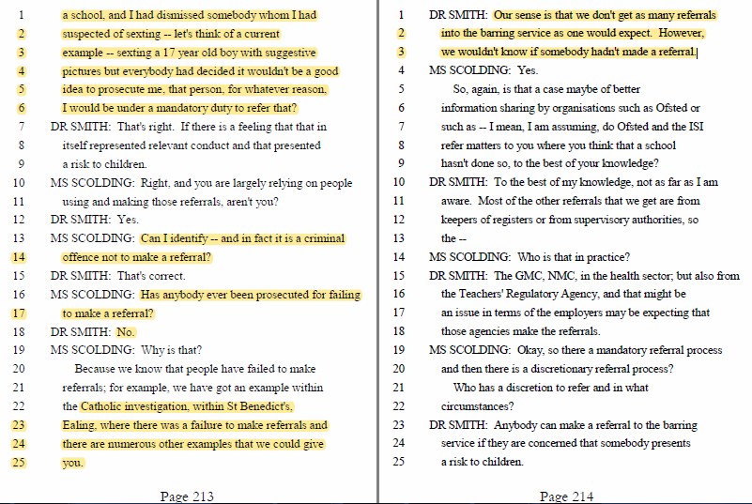
As a priority the DBS needs to be made effective in doing the job for which it was established. This Home Office proposal misunderstands why the introduction of well-designed mandatory reporting of suspected and known child sexual abuse is so important for personnel working with children and those employed in Regulated Activities.
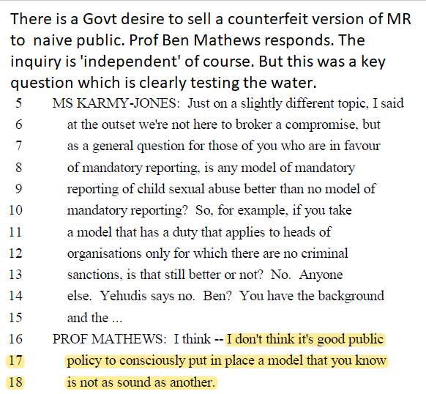
Question 15. Are there any costs or benefits which you think will be generated by the introduction of the proposed duty which have not been set out in the attached impact assessment?
There is no demonstrable improvement stemming from this proposal. According to the impact statement, the number of additional referrals is negligible compared to what is known (and stated by IICSA and the 2015 report of the Children’s Commissioner – just one in eight child abuse cases come to the attention of the statutory authorities) of the underlying offending rate. The changes anticipated in the impact statement are far less than those already achieved by the introduction of well-designed mandatory reporting of child sexual abuse in the various states of Australia, as documented by the papers of Mathews, Lamond et al.
We agree that the benefits from this proposal will be negligible because this proposal is not mandatory reporting. Well-designed mandatory reporting of child sexual abuse places a legal duty on defined people who work with children to report prescribed categories of events (and suspicions thereof). The government knows perfectly well how to define a mandatory reporting duty, since just such a duty exists with respect to money laundering in sections 330-334 of the Proceeds of Crime Act 2002 (as amended).
The page on the Home Office website which provides details of the consultation under the heading ‘Government proposals’’ then subheading ‘Consequences of breaching duty to report’ at paragraph 7, states:
7. All regulated professionals and teachers who are subject to the duty, including those working in private education and healthcare settings, will also be at a minimum subject to professional sanctions to be determined by the appropriate regulating body.
It becomes clearer still that the proposal for what this consultation incorrectly refers to as “mandatory reporting” lacks any of the features described in the first two paragraphs of our answer to this question.
- There is no statutory offence of failing to report.
- There is no criminal sanction for failing to report. Instead it is proposed that a DBS referral is made concerning the failure to report.
- It is not defined who (if anybody) will have the power or the duty to investigate suspected failures to report that might lead to a DBS referral.
- It is not an offence to fail to make an immediate referral to DBS where somebody has failed to report.
- It is not defined who will have the duty of making a referral to DBS in the event that somebody does not report, nor who has the power or duty to investigate suspected failures to make a DBS referral
- It is proposed that DBS referrals will be carried out under existing arrangements of SVGA 2006, but this only requires that a DBS referral is made in certain prescribed circumstances. It would appear there will be no obligation on anyone to make a DBS referral for failure to report abuse unless and until the suspected non-reporter is dismissed, removed from regulated activities or resigns their position.
- An additional form of professional sanction is proposed in place of a mandatory duty, without any suggestion as to:
  - How the professional bodies will be prevailed on to include reporting within their rules
  - How they will be prevailed on to enforce the rules (possibly against their own interests in maintaining the reputation of their profession)
  - What resources they will be provided with in order to enforce the rules
  - Who will have the authority to investigate suspected failures to report abuse that might lead to a professional sanction
  - How professional sanctions will apply to those “mandated reporters” who are not members of a professional body
The proposals are too weak to have any significant effect on reporting rates. This is reflected in the impact statement where the central estimate of the increase in reports is a mere 0.3%, or 310 extra referrals per year (less than one a year per local authority in England). This is well within the range of annual variation in reports as shown in the chart below from the Home Office funded CSA Centre (Control + click to open in new window)
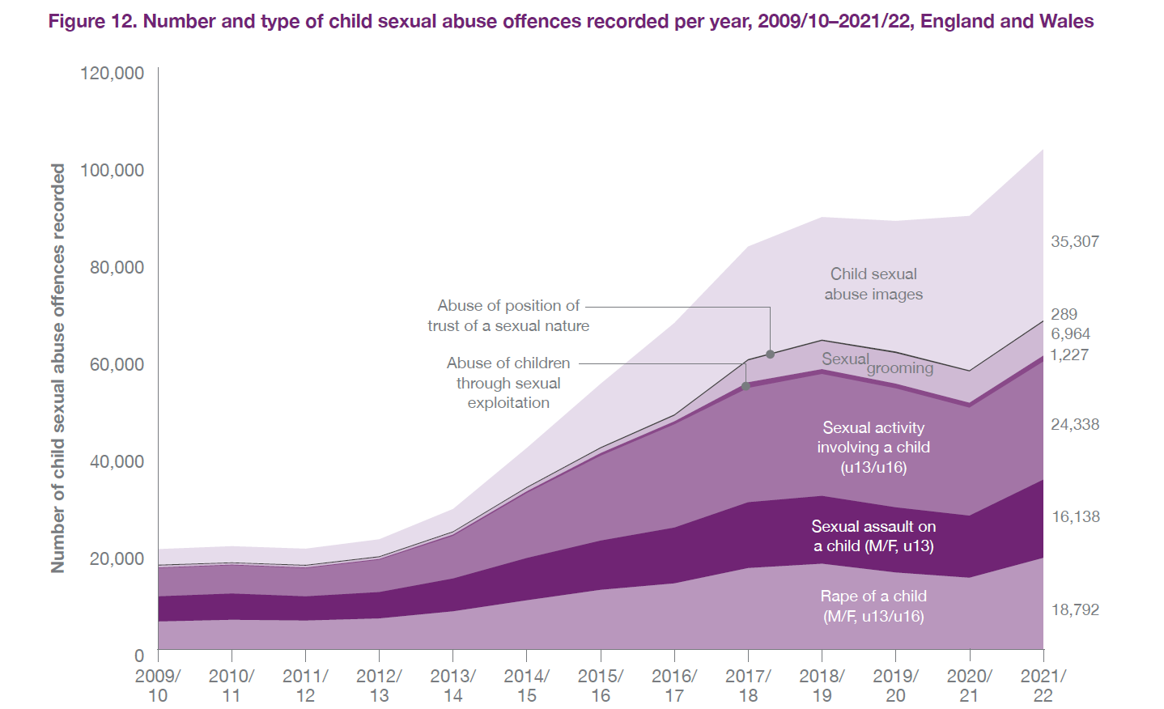
The overall impression is of a proposal designed to achieve nothing at all, while claiming to implement IICSA’s Recommendation 13 for mandatory reporting.
We notice that any monetizable benefits have carefully not been enumerated in the impact statement, while the costs have been enumerated at considerable length. It is perfectly possible to make an estimate of the benefit arising from prevented child sex abuse that would have occurred in the absence of action. The government has already estimated the costs of contact child sex abuse in its document “The economic and social cost of contact child sexual abuse”.
It would be relatively straightforward to have estimated the reduction in abuse arising from this measure, and then use the figures from that document to estimate the resulting monetizable benefit in terms of the avoided cost. Such an estimate should take into account the fact that abusers commonly abuse multiple victims, and that an abuser caught early by means of well-designed mandatory reporting would then ideally not have the opportunity to abuse subsequent victims. For the purpose of the calculation, a very rough (and conservative) estimate could be that each additional abuser caught as a result of mandatory reporting on average prevents three additional children being abused at all.
That this has not been done within the impact statement suggests that the government has no wish to acknowledge any such benefit might exist. As a consequence, it appears that government is prepared to leave abused children to their fate rather than take action that would lead to more crimes of child sexual abuse coming to the attention of the authorities. This would of course ensure that the authorities do not have to experience the costs attached to exercising their duty to protect more victims of child sexual abuse. Coincidentally, we wrote about this strategy in 2015.
The government takes measures (such as vaccination) to protect children from life-threatening or life-altering damage to their physical health but seems unable to treat the life-altering damage to the mental health of children arising from child sexual abuse as a public health matter in the same way.
The costs incurred from this lamentable Home Office proposition will be largely unseen as a result of very poor data collection. Recommendation 1 of the IICSA final report addressed the need for improved data collection, and no tangible action appears to have been taken by the government in response. However, good, evidence-based estimates are available in other jurisdictions. An insight into the likely impact of child abuse on the NHS is provided in this summary page from the significant Australian Child Maltreatment Study (2023) which randomly selected 8,500 Australians and surveyed them on 5 types of child maltreatment, 4 mental health disorders and the resulting health risk behaviours.
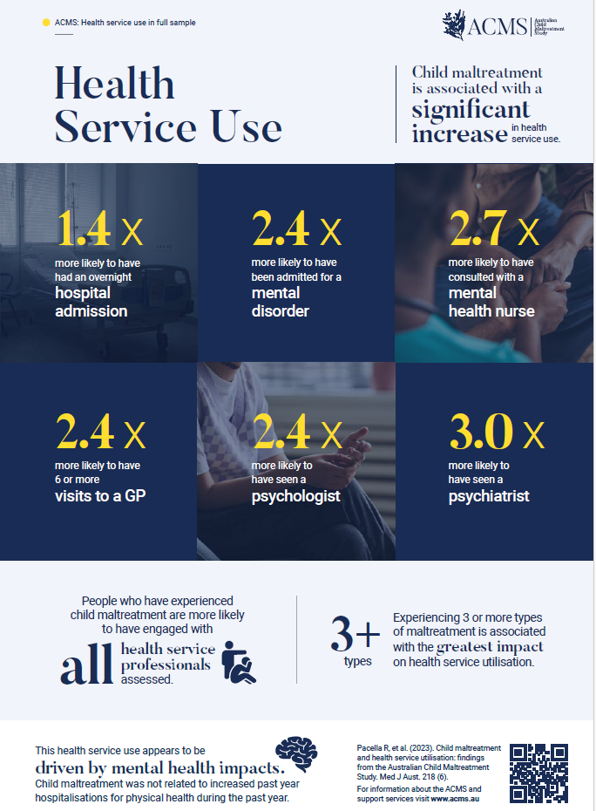
The population of Australia is 25.7m which is 45% that of England (60m). In 2020 the Productivity Commission estimated the annual cost of mental ill-health and suicide at between AUD $200-220 billion and that child maltreatment contributes substantially to this crippling national burden.
Mental health problems cost the UK economy at least £117.9 billion annually according to the report ‘The economic case for investing in the prevention of mental health conditions in the UK’ published in March 2022 by Mental Health Foundation and the London School of Economics and Political Science (LSE). In 2019 the cost to England was £101m – but this figure did not account for associated cost of reduced performance at work, unlike the Australian Child Maltreatment study.
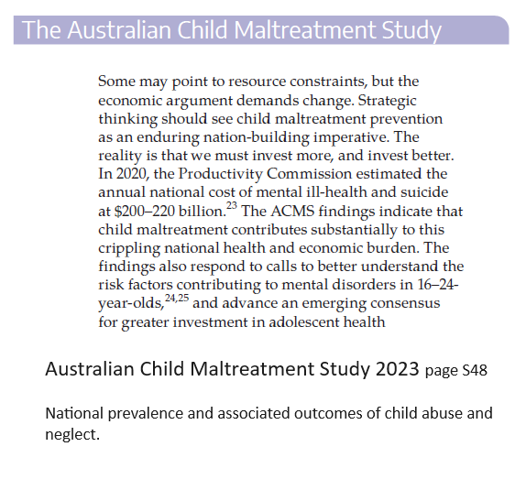
Prevalence data of mental health disorders stemming from child abuse.
Recommendation 8 in the ACMS:
A specific targeted area of high priority should be the enhanced prevention of child sexual abuse, through dedicated prevention efforts in schools focused on healthy development, attitudes to gender equality, emotional literacy, sexual literacy, and consent and relationships education. Child sexual abuse has significant qualitative differences to other maltreatment types, and improving prevention requires customised approaches in law, policy and practice.

This cannot be achieved with the Home Office proposal for which we can find no operating precedent anywhere in the world.

Question 16. In the light of the proposals outlined in this paper, what are the key implementation challenges and solutions reporters and organisations will face?
Please provide details to explain your response, including practical examples wherever possible.
In order that a well-designed mandatory reporting law as we propose (see our draft: Regulated and Other Activities (Mandatory Reporting of Child Sexual Abuse) can have maximum effect, the following measures also should be introduced:
- A standardised and accredited scheme for those providing safeguarding training. This needs to be comprised of professionals, companies and charities operating in the sector. It is essential that it has a democratic constitution and is not dominated by the large children’s NGOs’ which should be part of it.
- A standardised single scheme for training LADOs nationally.
- Statutory guidance which includes one or more model safeguarding policies for institutions affected by mandatory reporting (e.g. Schools, nurseries, sports clubs, youth clubs, places of worship)
- Inspection for safeguarding to be undertaken by a new specialist body. The advantage of an autonomous subject specific safeguarding inspectorate should be apparent to all. This new safeguarding inspectorate for schools will cause only minor inconvenience and break the link between safeguarding and education inspection that unfortunately exists. Educationalists do not make good safeguarding inspectors.
- Full and clear safeguarding inspection against DBS referrals returned by the settings since the previous inspection.
- Within four years of the introduction of well-designed mandatory reporting of known and suspected child sexual abuse, safeguarding inspections by the new safeguarding inspectorate to be extended to include sports clubs, youth clubs and places of worship.
- An effective triaging system operated by LADOs to assess referrals and assign resources accordingly. A specialist peer/peer sexual abuse assessor to triage referrals.
The Disclosure and Barring Service (“DBS”) to be constituted a competent prosecuting authority in cases of the non-return of a mandatory referrals as prescribed in SVGA 2006 as amended. The inherent weaknesses in this Act cannot be missed.

How to respond
Please email this response as an attachment to: mr_csa@homeoffice.gov.uk
Or you can print it and return to:
IICSA Response
Tackling Child Sexual Abuse Unit
Home Office
5th Floor, Fry Building
2 Marsham Street
London
SW1P 4DF

